1:write program to test Hello World.

class Program1

{

public static void main(String args[])

{

System.out.println("Hello World");

}

}

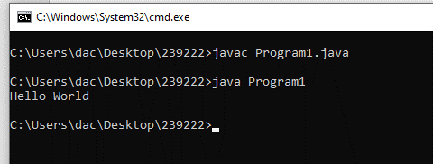

2:Write a program to adddition of two numbers .

import java.util.Scanner;

class Program2

{

public static void main(String atgs[])

{

Scanner stdin=new Scanner(System.in);

int num1,num2,sum=0;

System.out.print("Enter Number 1 ");

num1=stdin.nextInt();

System.out.print("Enter Number 2 ");

num2=stdin.nextInt();

sum=num1+num2;

System.out.println("Addition of 2 Nos : "+sum);

}

}

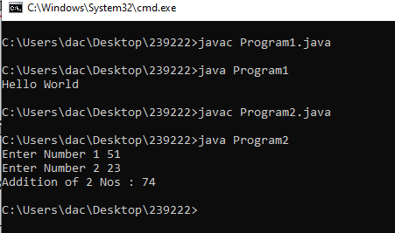

3:Write a program to swap two numbers.

import java.util.Scanner;

class Program3

{

public static void swapNumber(int[] arr)

{

int temp;

temp=arr[0];

arr[0]=arr[1];

arr[1]=temp;

}

public static void main(String atgs[])

{

Scanner stdin=new Scanner(System.in);

int[] arr=new int[2];

System.out.print("Enter Number 1 ");

arr[0]=stdin.nextInt();

System.out.print("Enter Number 2 ");

arr[1]=stdin.nextInt();

System.out.println("Before Swapping A = "+arr[0]+" and B = "+arr[1]);

swapNumber(arr);

System.out.println("After Swapping A = "+arr[0]+" and B = "+arr[1]);

}

}

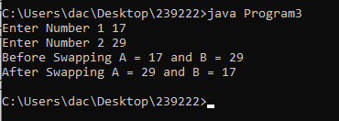

4. Write a program to accept an integer and check if it is even or odd.

import java.util.Scanner;

class Program4

{

public static void main(String atgs[])

{

Scanner stdin=new Scanner(System.in);

int num;

System.out.print("Enter a Number : ");

num=stdin.nextInt();

if(num%2==0)

System.out.println(num+" is Even");

else

System.out.println(num+" is Odd");

}

}

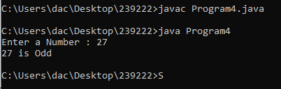

5. Write a program to accept a number and check if it is divisible by 5 and 7.

import java.util.Scanner;

class Program5

{

public static void main(String atgs[])

{

Scanner stdin=new Scanner(System.in);

int num;

System.out.print("Enter a Number : ");

num=stdin.nextInt();

if(num%5==0)

{

if(num%7==0)

{

System.out.println(num+" is Divisible by 5 and 7 Both");

}

else

{

System.out.println(num+" is Divisible by Only 5");

}

}

else if(num%7==0)

{

System.out.println(num+" is Divisble by only 7");

}

else

System.out.println(num+" is not Divisible by 5 or 7 Both");

}

}

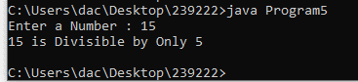

6. Write a program, which accepts annual basic salary of an employee and calculates and displays the

Income tax as per the following rules.

Basic: < 1, 50,000 Tax = 0

1, 50,000 to 3,00,000 Tax = 20%

> 3,00,000 Tax = 30%

import java.util.Scanner;

class Program6

{

public static void main(String atgs[])

{

Scanner stdin=new Scanner(System.in);

int salary;

double iTax;

System.out.print("Enter Salary : ");

salary=stdin.nextInt();

if(salary>300000)

iTax=salary\*0.30;

else if(salary<300000 && salary >150000)

iTax=salary\*0.20;

else

iTax=0;

System.out.println("Income Tax : Rs "+iTax);

}

}

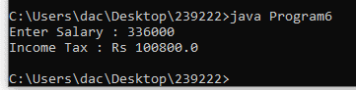

7. Accept a lowercase character from the user and check whether the character is a vowel or consonant.

(Hint: a, e, i, o, u are vowels)

import java.util.Scanner;

class Program7

{

public static void main(String atgs[])

{

Scanner stdin=new Scanner(System.in);

char ch;

boolean v=false;

System.out.print("Enter a Character : ");

ch=stdin.next().charAt(0);

char[] vowel={'a','e','i','o','u','A','E','I','O','U'};

for(char c:vowel)

{

if(ch==c)

{

v=true;

break;

}

}

if(v)

System.out.println(ch+" is Vowel");

else

System.out.println(ch+" is Consonent");

}

}

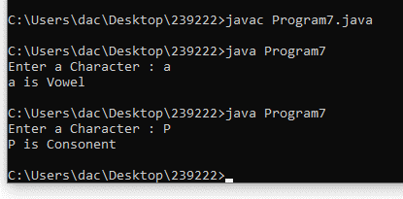

8. Write a program to input angles of a triangle and check whether triangle is valid or not.

import java.util.Scanner;

class Program8

{

public static void main(String atgs[])

{

Scanner stdin=new Scanner(System.in);

int angle1,angle2,angle3;

System.out.print("Enter Angle 1 : ");

angle1=stdin.nextInt();

System.out.print("Enter Angle 2 : ");

angle2=stdin.nextInt();

System.out.print("Enter Angle 3 : ");

angle3=stdin.nextInt();

if((angle1+angle2+angle3) > 180)

System.out.println("Given Triangle is NOT Valid");

else

System.out.println("Given Triangle is Valid");

}

}

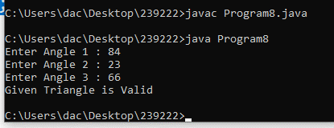

9:Write a program to find factorial of a given number. ex:no5 fact=5\*4\*3\*2\*1=120

import java.util.Scanner;

class Program9

{

public static void main(String atgs[])

{

Scanner stdin=new Scanner(System.in);

int num,fact=1;

System.out.print("Enter a Number : ");

num=stdin.nextInt();

for(int i=1;i<=num;i++)

fact=fact\*i;

System.out.println("Factorial of "+num+" is "+fact);

}

}

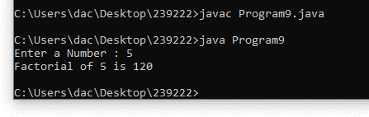

10:Write a program to find m to the power n. m=3 and n=4 so 3\*3\*3\*3

import java.util.Scanner;

class Program10

{

public static void main(String atgs[])

{

Scanner stdin=new Scanner(System.in);

int m,n;

System.out.print("Enter M : ");

m=stdin.nextInt();

System.out.print("Enter N : ");

n=stdin.nextInt();

System.out.println(m+" Power "+n+" is "+Math.pow(m,n));

}

}

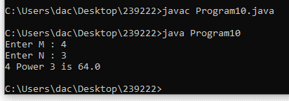

11:Check if number is a prime number or not.:

import java.util.Scanner;

class Program11

{

public static void main(String atgs[])

{

Scanner stdin=new Scanner(System.in);

int num;

System.out.print("Enter a Number : ");

num=stdin.nextInt();

int fact=2;

for(int i=2;i<num;i++)

{

if(num%i==0)

{

fact++;

break;

}

}

if(fact==2)

System.out.println(num+" is Prime Number ");

else

System.out.println(num+" is NOT Prime Number ");

}

}

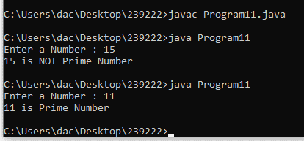

12:Sum of series :

1+2+3+….+n

import java.util.Scanner;

class Program12

{

public static void main(String atgs[])

{

Scanner stdin=new Scanner(System.in);

int num,sum=0;

System.out.print("Enter a Number : ");

num=stdin.nextInt();

for(int i=1;i<=num;i++)

{

sum=sum+i;

System.out.print(i);

if(i==num)

break;

System.out.print("+");

}

System.out.print("="+sum);

}

}

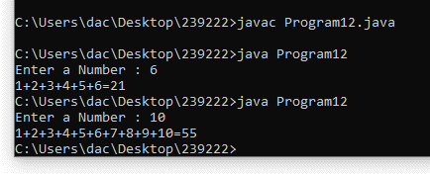

13:Check whether the number is palindrome or not?

14:Write a program to find sum of all even and odd numbers between 1 to n.

import java.util.Scanner;

class Program14

{

public static int primeNo(int num)

{

int fact=2;

for(int i=2;i<num;i++)

{

if(num%i==0)

{

fact++;

break;

}

}

if(fact==2)

return num;

else

return 0;

}

public static void main(String atgs[])

{

Scanner stdin=new Scanner(System.in);

for(int i=1;i<=100;i++)

{

if(primeNo(i)>0)

System.out.print(i+" ");

}

}

}

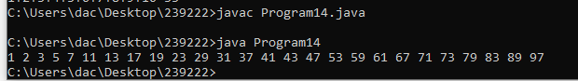

15: Write a program to enter a number and print its reverse.

import java.util.Scanner;

class Program15

{

public static void main(String atgs[])

{

Scanner stdin=new Scanner(System.in);

int num;

System.out.print("Enter a Number : ");

num=stdin.nextInt();

System.out.println("Number : "+num);

StringBuffer ss=new StringBuffer(Integer.toString(num));

String txt=new String(ss.reverse());

num=Integer.parseInt(txt);

System.out.println("Reverse : "+num);

}

}

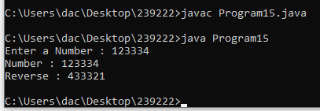

16:Write a program to print all Prime numbers between 1 to n.

17:Write a program to check entered number is Armstrong number or not.

18:Write a program to find greatest of three numbers using nested if-else.

import java.util.Scanner;

class Program18

{

public static void main(String args[])

{

Scanner sin=new Scanner(System.in);

int a,b,c;

System.out.print("Enter Number 1 : ");

a=sin.nextInt();

System.out.print("Enter Number 2 : ");

b=sin.nextInt();

System.out.print("Enter Number 3 : ");

c=sin.nextInt();

if(a>b && a>c)

System.out.println(a+" is Greater of 3 Nos");

else if(b>c)

System.out.println(b+" is Greater of 3 Nos");

else

System.out.println(c+" is Greater of 3 Nos");

}

}

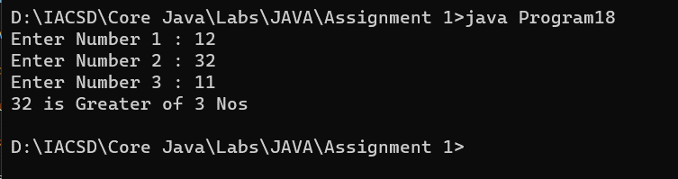

19:Create menu driven program for Pizza Shop.And display total amount,

20:Accept a single digit from the user and display it in words. For example, if digit entered is 9, display Nine.

import java.util.Scanner;

class Program20

{

public static void main(String args[])

{

Scanner sin=new Scanner(System.in);

int num;

System.out.print("Enter Single Digit Number : ");

num=sin.nextInt();

switch(num)

{

case 1:System.out.println("ONE");break;

case 2:System.out.println("TWO");break;

case 3:System.out.println("THREE");break;

case 4:System.out.println("FOUR");break;

case 5:System.out.println("FIVE");break;

case 6:System.out.println("SIX");break;

case 7:System.out.println("SEVEN");break;

case 8:System.out.println("EIGHT");break;

case 9:System.out.println("NINE");break;

case 0:System.out.println("ZERO");break;

default:System.out.println("Enter Only Single Digit");break;

}

}

}

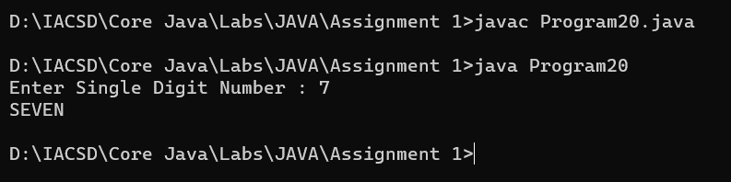

21. Write a program, which accepts two integers and an operator as a character (+ - \* / ), performs the

corresponding operation and displays the result.

import java.util.Scanner;

class Program21

{

public static void main(String atgs[])

{

Scanner stdin=new Scanner(System.in);

int num1,num2,result=0,choice;

char op;

System.out.print("Enter Number 1 ");

num1=stdin.nextInt();

System.out.print("Enter Number 2 ");

num2=stdin.nextInt();

System.out.print("Enter Operator : ");

op=stdin.next().charAt(0);

switch(op)

{

case '+':result=num1+num2;

break;

case '-':result=num1-num2;

break;

case '\*':result=num1\*num2;

break;

case '/':result=num1/num2;

break;

default:

System.out.println("Enter Correct Operator");

}

System.out.println("Result = "+result);

}

}

